DOCUMENTATION

ASSIGNMENT 2

STUDENT NAME: CORNOC DARIUS ANDREI
GROUP: 30423

CONTENTS

1. Assignment Objective 3
2. Problem Analysis, Modeling, Scenarios, Use Cases 3
3. Design 5
4. Implementation 6
5. Results 8
6. Conclusions 8
7. Bibliography 9

Assignment Objective
The assignment’s objective is to design and implement an application aiming to analyze queuing-based systems by simulating a series of N clients arriving for service, entering Q queues, waiting, being served and finally leaving the queues, and computing the average waiting time, average service time and peak hour.

The sub-objectives needed for attaining this aim are:
- Analyze the problem and identify requirements
- Design the simulation application
- Implement the simulation application
- Test the simulation application

Problem Analysis, Modeling, Scenarios, Use Cases
The functional requirements for the queue management application are the following:
- The simulation application should allow users to setup the simulation
- The simulation application should allow users to start the simulation
- The simulation application should display the real-time queues
- The simulation application should provide statistics and metrics about the simulation, such as average waiting time and peak hour

The non-functional requirements of the project are:
- The user interface should be intuitive and easy to use
- The simulation application should handle errors by providing informative error messages to the user when necessary
- The simulation application should be responsive and performant, even when simulating large numbers of clients and servers

The use case diagram presented below illustrates the various interactions between the users and the system of the queue management application.

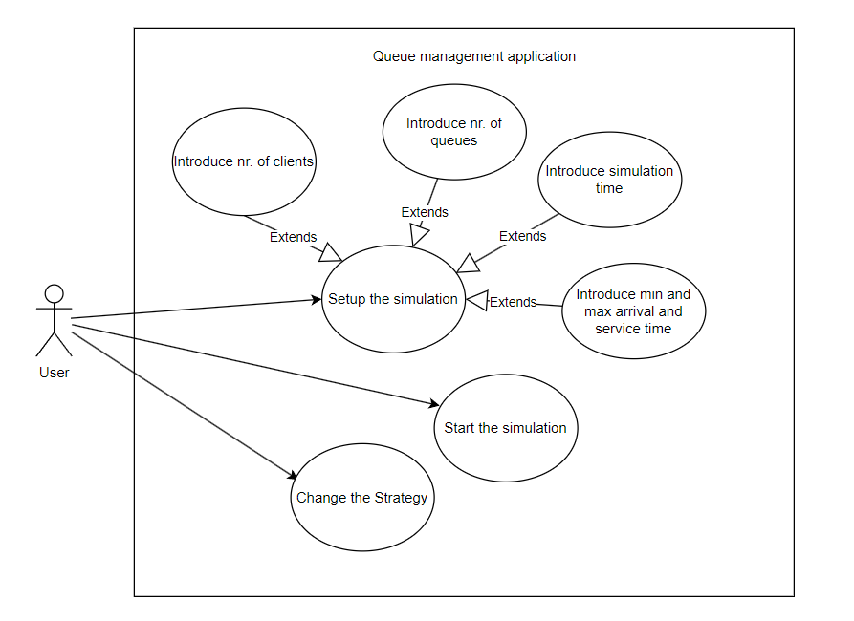
Figure 1. Use case diagram

The use case descriptions will be provided in the next part:

- Use Case: setup and start of the simulation
Primary Actor: User
Main Success Scenario:
- The user inserts the values for the: number of clients, number of queues, simulation interval, minimum and maximum arrival time, and minimum and maximum service time
- The user clicks on the start button
- The application validates the data and displays a message informing the user to start the simulation
Alternative Sequence:
- The user inserts invalid values for the application’s setup parameters
- The application displays an error message and requests the user to insert valid values
- The scenario returns to step 1

- Use Case: change strategy
Primary Actor: User
Main Success Scenario:
- The user selects between the shortest time strategy or the shortest queue strategy for allocating clients to the queues

Design
The design is divided on more levels. The first level involves dividing the system into packages. The graphical user interface contains the classes that will deal with the interface presented to the user. The business logic package contains the classes that perform management of the simulation setup by the user. The data models package contains the classes modeling the application.

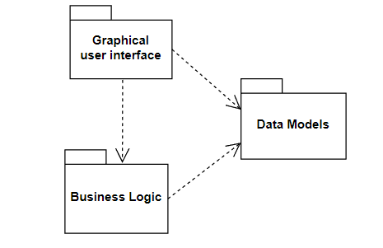
Figure 2. UML package diagram

The second level is represented by the class diagram design. Designing a class diagram involves structuring and organizing the classes and establishing the relationships between them.
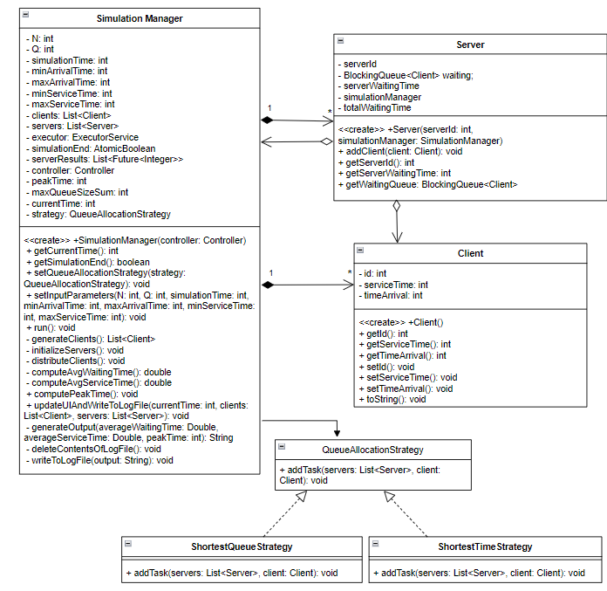
Figure 5. UML class diagram

Implementation
- The SimulationManager class is a crucial component of the queue management simulation application. It orchestrates the simulation by managing clients, servers, and the overall simulation process. The important fields are:
- N: Represents the number of clients to be simulated.
- Q: Represents the number of servers in the simulation.
- simulationTime: Represents the duration of the simulation in time units.
- minArrivalTime, maxArrivalTime: Define the range of arrival times for clients.
- minServiceTime, maxServiceTime: Define the range of service times for clients.
- clients: List of clients participating in the simulation.
- servers: List of servers available for serving clients.
- simulationEnd: AtomicBoolean to signal the end of the simulation.
- serverResults: List of Futures representing the results of server callables.
- controller: Reference to the GUI controller for updating the UI.
- strategy: Represents the strategy for allocating clients to servers.

The important methods of this class are:
- setQueueAllocationStrategy(QueueAllocationStrategy strategy): Sets the strategy for allocating clients to servers.
- setInputParameters(): Sets the input parameters for the simulation.
- run(): Main method to run the simulation. It orchestrates the simulation process.
- generateClients(): Generates a list of clients based on the input parameters.
- distributeClients(): Distributes clients to servers based on the defined strategy.
- computeAvgWaitingTime(): Computes the average waiting time across all servers.
- computeAvgServiceTime(): Computes the average service time across all servers.
- computePeakTime(): Computes the peak time during the simulation.
- updateUIAndWriteToLogFile(): Updates the GUI with simulation information and writes to a log file.

- The Server class in the queue management simulation application represents a server entity that serves clients. The important fields of this class are:
- waiting: BlockingQueue of clients waiting to be served by the server.
- totalWaitingTime: represents the total waiting time of clients in the server's queue.
- serverId: identifier for the server.
- serverWaitingTime: represents the current waiting time of clients in the server's queue.
- simulationManager: reference to the SimulationManager for coordination and communication.

The important methods of the Server class are:
- call(): Implements the Callable interface. This method represents the server's behavior during the simulation. It continuously serves clients until the simulation ends or the queue becomes empty. First it dequeues clients from the waiting queue and serves them one by one. Then, it decrements the service time of clients until they are served. It updates the total waiting time of clients served by the server. Finally, it returns the average waiting time of clients served by the server.
- addClient(Client client): Adds a client to the server's waiting queue and updates the server's waiting time.
- The Client class in the queue management simulation application represents a customer entity that arrives at the system to be served. The important fields are:
- id: identifier for the client.
- timeArrival: represents the time at which the client arrives at the system.
- serviceTime: represents the time it takes for the client to be served.

In the context of the queue management application, the Strategy Pattern is implemented to dynamically select between different strategies for allocating clients to queues.
The Strategy interface defines a common interface for queue allocation strategies. Concrete strategies are the actual implementations of the queue allocation strategies. Each concrete strategy class implements the methods defined in the strategy interface, providing a specific algorithm for allocating clients to queues.
The ShortestTimeStrategy allocates clients to queues based on the arrival time of clients. It may prioritize queues with shorter waiting times.
The ShortestQueueStrategy allocates clients to queues based on the current queue lengths. It may prioritize queues with shorter lengths.

Results

The results of the run of the application on the data sets provided in the requirements file can be seen in the repository.

Conclusions
In conclusion, the queue management application demonstrates the effective use of object-oriented principles and design patterns to create a flexible and extensible system for managing queues in a simulation environment. By implementing features such as dynamic queue allocation strategies and real-time visualization of queues, the application provides valuable insights into queue management and optimization.

Through this assignment, I have gained a deeper understanding of various concepts and techniques in software development, including:
- Design Patterns: I have learned how to apply design patterns such as the Strategy Pattern to solve common design problems and promote code reusability and maintainability.
- Multi-threading: Implementing multi-threading in Java using Executors and Futures allowed me to simulate concurrent processing and manage asynchronous tasks effectively.
- File I/O Operations: Implementing file writing operations allowed me to persist simulation data and generate log files for analysis.

One way the queue management application could be further developed and improved is by enhancing the visualization. This would mean to add graphical representations of queues and client movement within the simulation environment.

Bibliography
- Bruce Eckel, Thinking in Java (4th Edition), Publisher: Prentice Hall PTRUpper Saddle River, NJUnited States, ISBN:978-0-13-187248-6 Published:01 December 2005.
- https://dsrl.eu/courses/pt/materials/PT2024_A2.pdf
- https://dsrl.eu/courses/pt/materials/PT_2024_A2_S1.pdf

